**Project**

**JSPR-Techies**

**Checkpoint 2  
  
11/20/2023**

**Members**

Jayani Sumanka Gerine

Pallavi Dabade

Raksha Varahamurthy

### Surya Subramani

**Table of Contents**

Project Title & Members……………………………….…………….……. 1

Current Iteration Updates…………………………………………………. 3

List of User Stories Completed……………………….…………….……. 3

New User Stories in the Current Iteration from backlog……..….…… .6

Changes to the Existing User Stories..……………….…………………. 7

Breakdown of the existing User Stories……………….………………… 8

Functionality Completed by the current iteration………………………. 9

Lesson Learned……………………………………………………………. 11

List of the User Stories Yet to Implement………………..……………… 12

Next Iteration Updates…………………………………………………….. 16.

List of User Stories for Next Iteration………………………..…………… 19

Functionality Completed by Next Iteration………………………………. 21

New User Stories for Next Iteration……………………..……………… 22

**Current Iteration Updates - 11/10/23 to 11/20/23**

**List of User Story Completed**

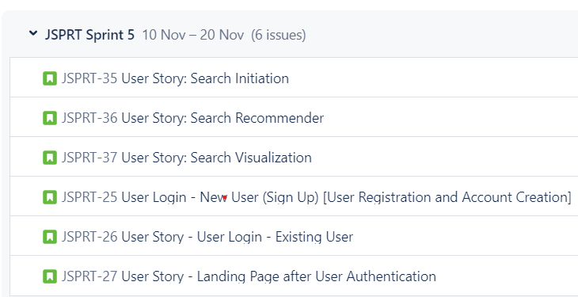

1. **Search Initiation Enhancement**

**Size**: 3

**User Role**: Student, Faculty, and Alumni of University of Michigan

**Goal**: Allow users to enter search keywords.

**Reason**: To provide users with the ability to search for articles based on their interests.

**Preconditions**:

* Users should be logged into the JSPR-Tec blog.
* The search bar is accessible on the user interface.

**Triggers**: The user accesses the JSPR-Techies blog.

**Postcondition**: Users should be able to initiate a search by clicking on the submit button.

**Exceptions**:

* If the user is not logged in, they will be prompted to log in before initiating a search.
* Technical issues affecting the search functionality may prevent users from initiating a search.

*(The below shown snap is the prototype implementation and Code Snippet)*

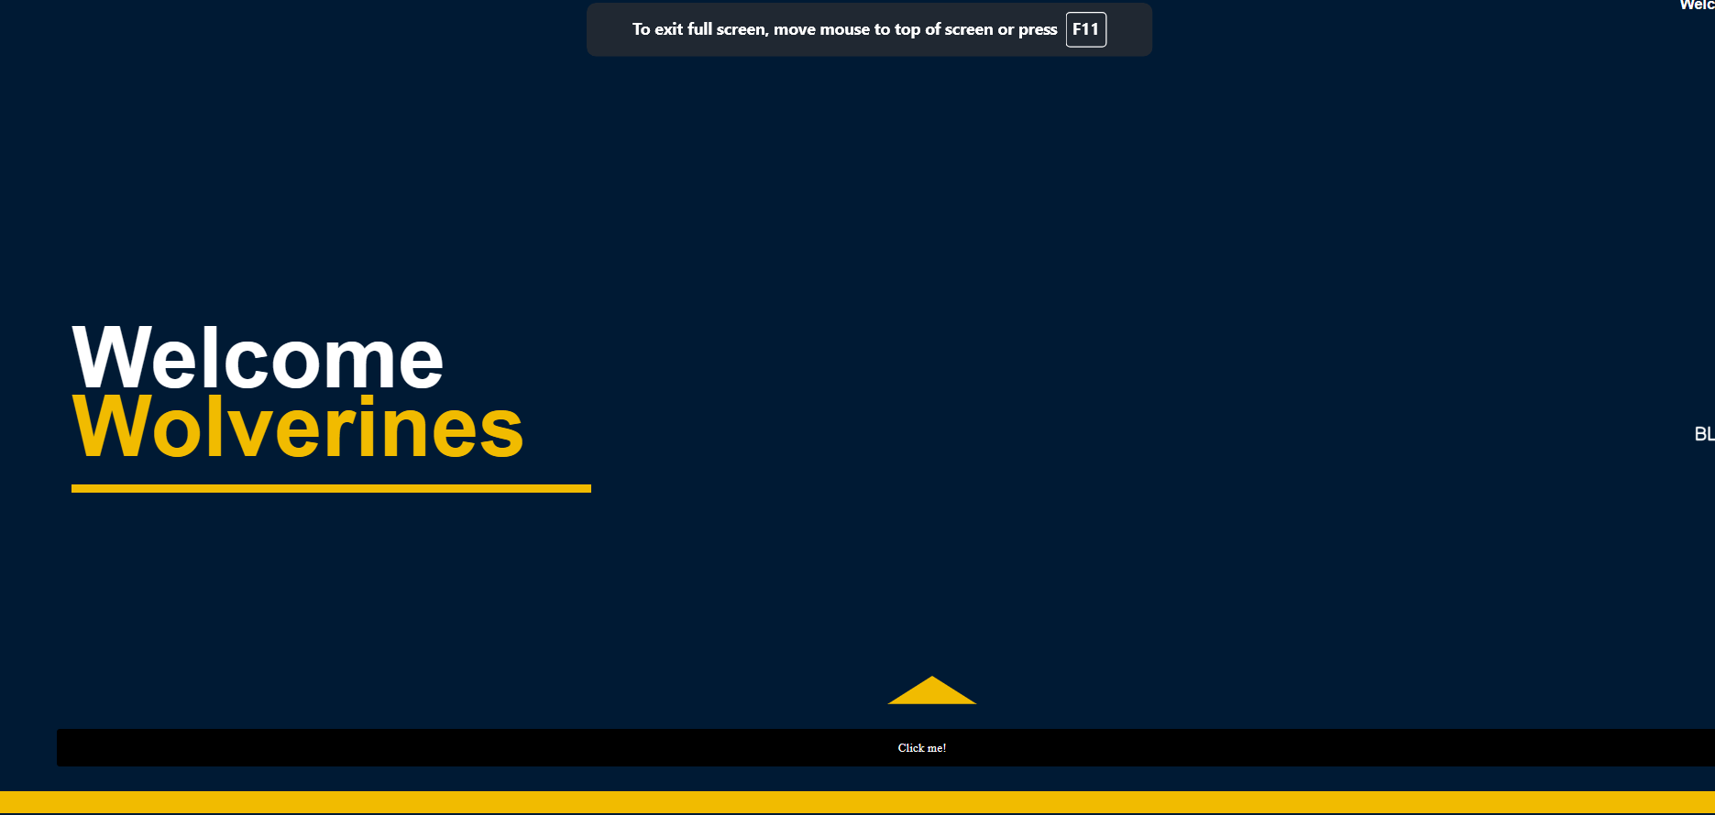 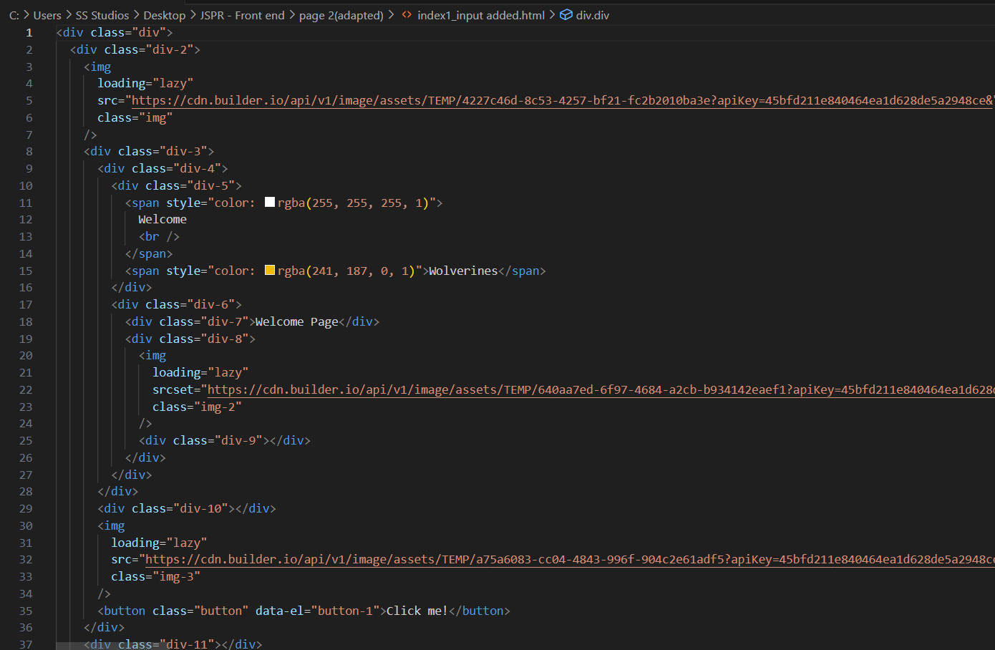

1. **Search Recommender Improvement**

**Size**: 3

**User Role**: Developer

**Goal**: Enhance the recommendation system to recommend the top 5 articles by matching entered keywords to an AI model.

**Reason**: To provide users with more accurate and relevant article recommendations.

**Preconditions**:

* Users should have entered keywords to initiate the search.
* The AI model for recommendations is in place.

**Triggers**: The user initiates a search or provides search keywords.

**Postcondition**: Improved article recommendations will be returned.

**Exceptions**:

* If the AI model encounters errors or fails to provide recommendations, users may receive suboptimal or no recommendations.

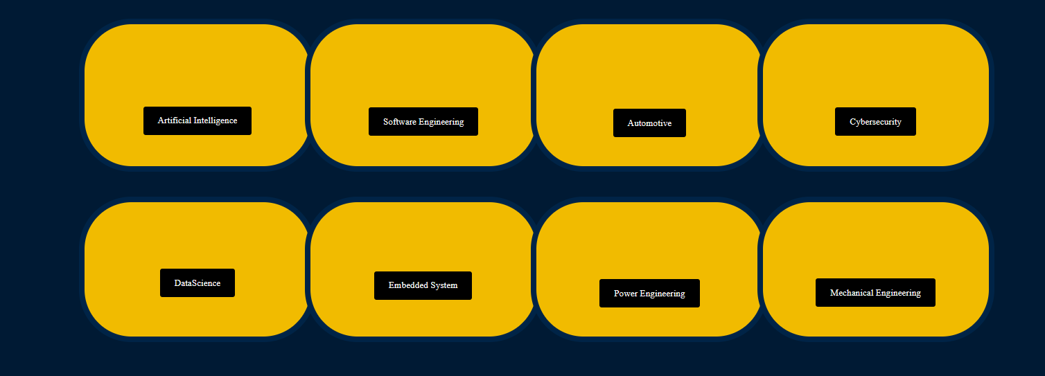 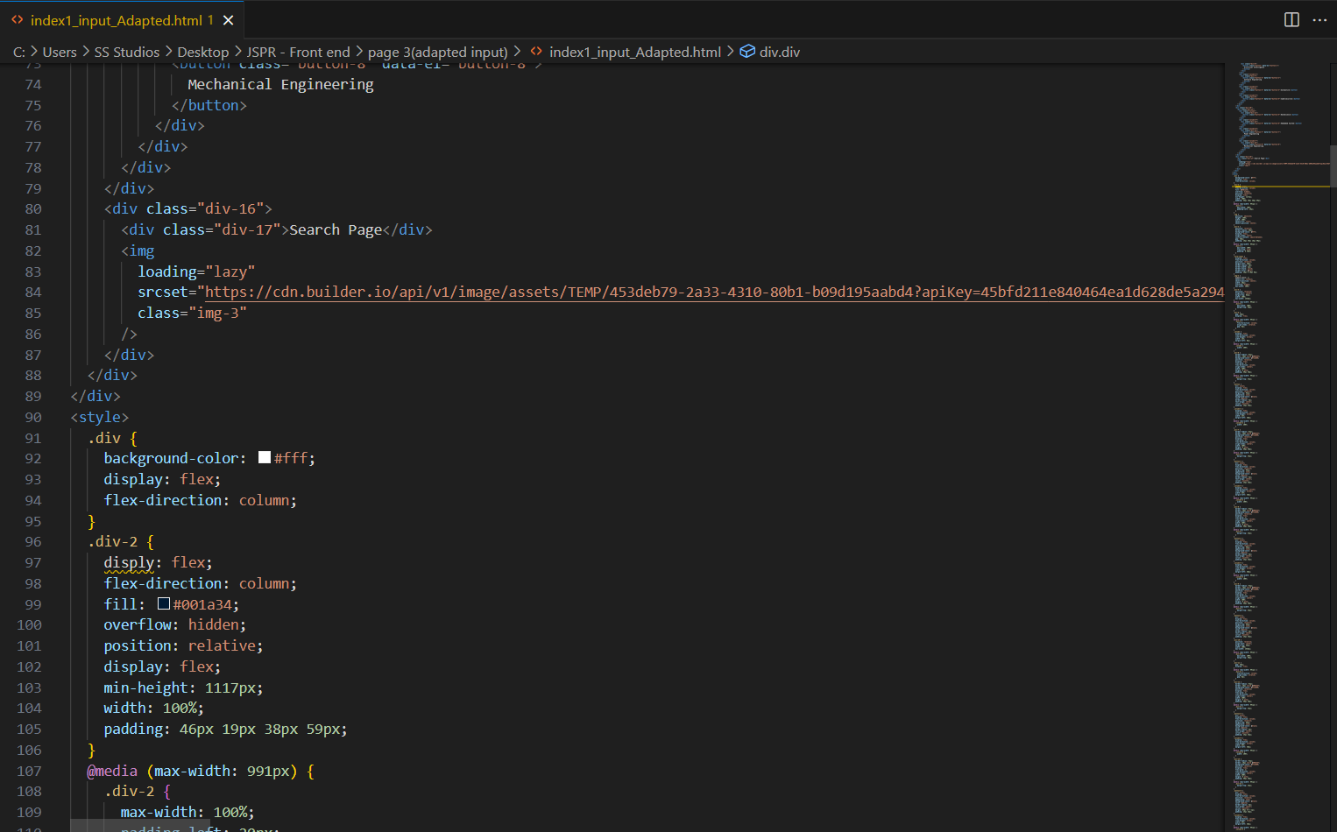

1. **Search Visualization Enhancement**

**Size**: 3

**User Role**: Student, Faculty, and Alumni of University of Michigan

**Goal**: Display the top 5 articles recommended by the AI model on the recommended articles page.

**Reason**: To make it easier for users to access and explore recommended articles.

**Preconditions**:Search recommenders should have identified articles matching search keywords.

**Triggers**: Users access the recommended articles page.

**Postcondition**: Users should be able to click on the required article from the list of articles.

**Exceptions**:

* If the recommended articles are not available or if there are technical issues in displaying them, users may not be able to access the recommended articles.

*(The below shown snap is the prototype implementation)*

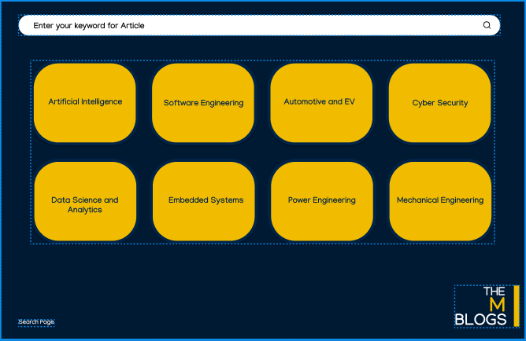

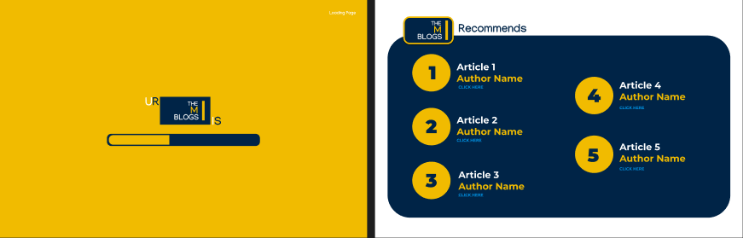

**New User Story in the Current Iteration from the backlog**

1. **User Registration and Account Creation**
   * **Size:** 5
   * **User Role:** Student, Faculty, and Alumni of University of Michigan
   * **Goal:** Display html page for user registration
   * **Trigger**: New users accessing the JSPR-Techies blog.
   * **Preconditions:** User enter umich id and click the submit button
   * **Normal Operations**:
     + New users land on the login page.
     + Users create accounts using unique usernames and their email addresses as passwords.
   * **Post conditions:** User successfully login
   * **Exception**:
     + If the domain name is not recognized or the registration process encounters errors, users may not be able to create accounts.
2. **User Login**
   * **Size:** 5
   * **User Role:** Student, Faculty, and Alumni of University of Michigan
   * **Goal:** Display html page for user registration
   * **Trigger:** Existing users accessing the JSPR-Techies blog enter umich id and click submit button.
   * **Preconditions:** User enter umich id and click the submit button
   * **Post conditions:** User successfully login
   * **Normal Operations**:
     + Existing users land on the login page.
     + Users enter their unique usernames and email addresses to log in.
   * **Exception**:
     + If the entered credentials do not match, users won't be able to log in.
3. **Landing Page After User Authentication**
   * **Size:** 5
   * **User Role:** Student, Faculty, and Alumni of University of Michigan
   * **Trigger:** Users successfully log in and land on the blog page.
   * **Preconditions:** User login using umich id and get authenticated
   * **Post conditions:** User able to access the search functionality
   * **Normal Operations**:
     + Authenticated users land on the JSPR-Techies blog's home page and see a welcome message.
   * **Exception**:
     + If users enter incorrect credentials or fail to authenticate, they won't reach the landing page.

**Changes in the existing User Stories**

**User Login Page Enhancement for JSPR-Techies Blog:**

* + **Size:** 5
  + **User Role:** Student, Faculty, and Alumni of University of Michigan
  + **Goal:** Enhance the HTML page for user registration on the JSPR-Techies blog.
  + **Trigger:** Existing users accessing the JSPR-Techies blog enter their Umich ID and click the submit button.
  + **Preconditions:** Users enter their Umich ID and click the submit button.
  + **Postconditions:** Users successfully log in.
  + **Normal Operations:**
    - Existing users navigate to the improved login page.
    - The enhanced page allows users to enter their unique usernames and email addresses for login.
  + **Exception:**
    - If the entered credentials do not match, users will receive feedback indicating unsuccessful login attempts.

As part of this enhancement, we prioritize not only the functionality but also the aesthetics of the user login page. By integrating interactive GIFs, logos, and vectors, we aim to make the login process more visually appealing and user-friendly. This design enhancement is intended to provide a seamless and enjoyable experience for users, including students, faculty, and alumni of the University of Michigan, as they interact with the JSPR-Techies blog.

**Break down of the existing User Story**

The below mentioned user story serves as a detailed breakdown derived from the broader set of user stories related to the search page enhancements. It specifically addresses the user's ability to navigate major topic blocks, providing a more granular view of how users can explore and access top articles within specific topics directly from the search page. By breaking down the functionality into smaller, focused user stories, the development team can efficiently implement and enhance different aspects of the search page experience for JSPR-Techies blog users.

**Major Topic Block Navigation Enhancement**

* + **Size:** 3
  + **User Role:** Student, Faculty, and Alumni of the University of Michigan
  + **Goal:** Enable users to click on major topic blocks on the search page to access the top five articles under that specific topic.
  + **Reason:** To offer users a convenient way to explore and access the most relevant articles within a specific major topic.
  + **Preconditions:** 
    - Users should be logged into the JSPR-Tec blog.
    - **The major topic blocks are visibly displayed on the search page.**
  + **Triggers:** The user accesses the search page on the JSPR-Techies blog.
  + **Postcondition:** Users should be able to click on a major topic block to view the top five articles related to that specific topic.
  + **Exceptions:**
    - If the user is not logged in, they will be prompted to log in before accessing major topic blocks.
    - In the event of technical issues affecting the functionality, users may face limitations in navigating and accessing top articles under major topics.

**Functionality Completed by the end of current Iteration** -

What functionality does the system have at the end of this iteration? (2 pts)

**Completed Frontend Development and Integration with Backend:**

The frontend development for the JSPR-Techies blog has been successfully completed, and it has been seamlessly integrated with the backend. This integration ensures a smooth flow of data and interactions between the user interface and the server.

**User Able to Login Using Umich ID:**

Users can now log in to the JSPR-Techies blog using their University of Michigan (Umich) student ID. This provides a secure and university-verified authentication process, ensuring that only valid Umich students have access to the blog.

**Access to Home Page After Successful Login:**

After successfully logging in, users are directed to the home page, serving as the landing page for the JSPR-Techies blog. This page serves as the central hub for accessing various features and content within the blog.

**Search Functionality:**

Users have the capability to enter search keywords in the designated search text box and initiate a search by pressing enter. This search functionality enhances the user experience by allowing them to quickly find relevant content within the JSPR-Techies blog.

**Improved Article Recommendations:**

The system incorporates enhanced search functionality and improved algorithms for article recommendations. This refinement ensures that users receive more accurate and relevant article suggestions based on their interests and search queries.

**Better User Experience:**

The overall user experience has been enhanced through improved search capabilities and article recommendations. Users can now initiate searches, receive more accurate recommendations, and easily access the suggested articles, contributing to a more satisfying and tailored user experience.

**Tailored and Satisfying User Experience:**

The search and recommendation capabilities of the system have been refined to offer a more tailored and satisfying user experience. This includes personalized content recommendations, a user-friendly interface, and efficient navigation to make the exploration of articles on the JSPR-Techies blog enjoyable for Umich students.

**Screenshots**:

LOG IN - Flask API

Accepting the users Umich ID, once submitted it allows the user to move to step to select the department.

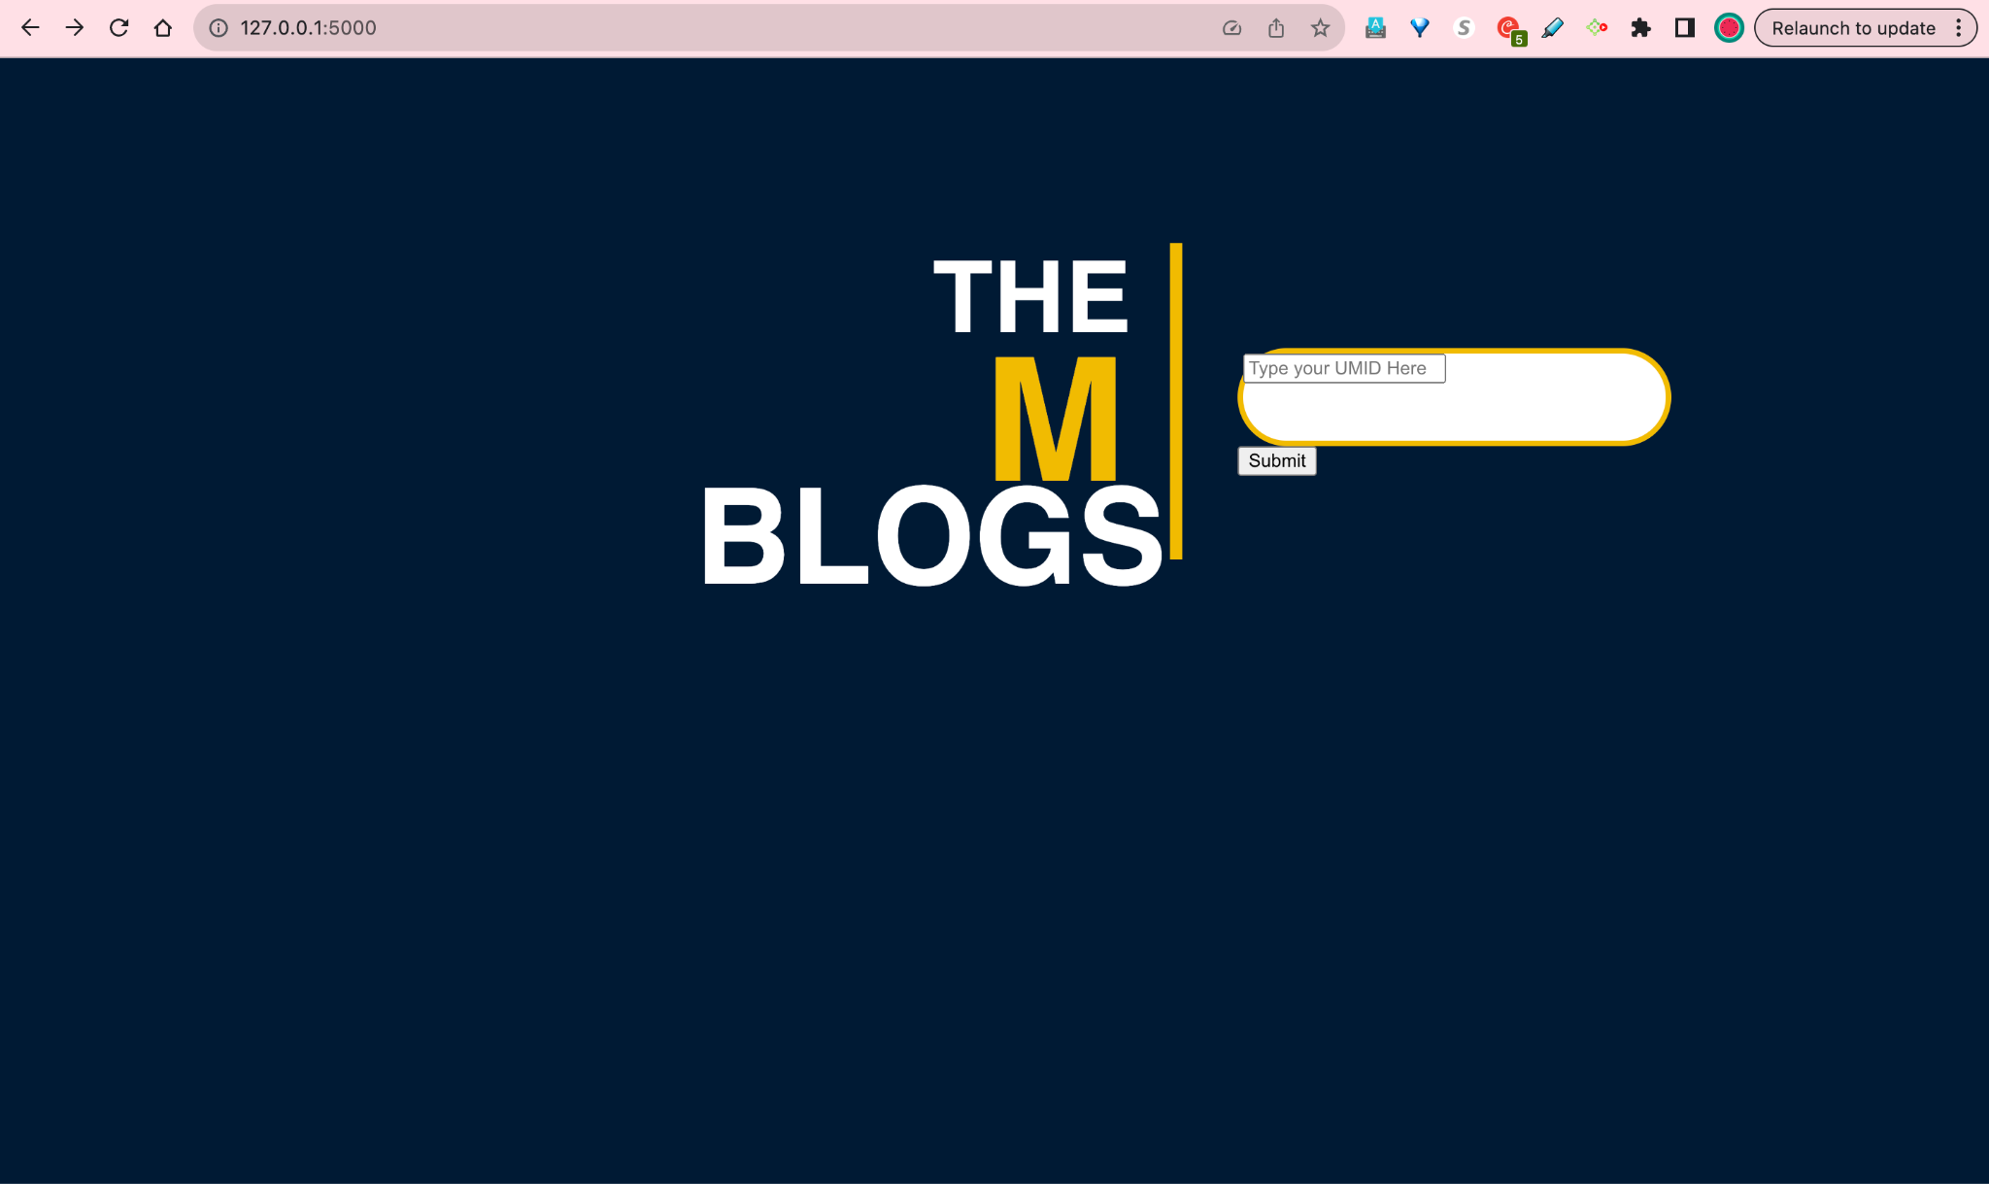

Flask API connected to Mysql database through SQLAlchemy toolkit.

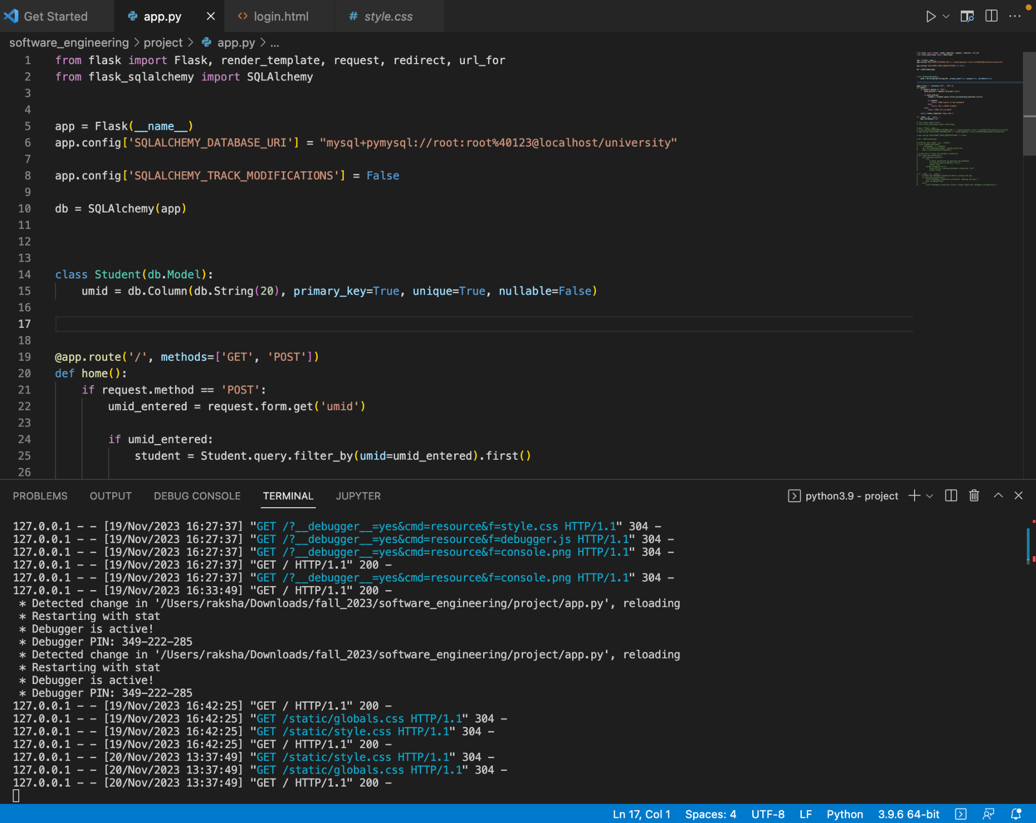

**Lesson Learned of Iteration**

What are the "lessons learned" at the end of this iteration? What would you do differently next time? Explain. (2 pts)

**Frontend development**

Throughout the frontend development process, several key lessons have been gleaned, contributing to a refined and efficient workflow:

**Structured HTML Files and CSS Styling:**

Lesson: Initiating the development process with well-structured HTML files and the application of CSS styling is foundational. This approach ensures a clear and organized foundation for building the frontend, fostering easier collaboration among developers and facilitating future updates.

**Python for HTML Parsing and Backend Connectivity:**

Lesson: Leveraging Python for parsing HTML code and establishing connections with backend endpoints has proven to be a strategic choice. This integration enhances the accessibility of backend data within the HTML, promoting seamless communication between the frontend and backend components.

**Browser Inspection for Functionality Verification:**

Lesson: Regularly inspecting HTML files in the browser during development is a valuable practice. This step aids in verifying that the implemented functionality aligns with expectations, providing developers with real-time insights and facilitating prompt issue identification.

**Use of Debuggers for Issue Resolution:**

Lesson: Utilizing debuggers has emerged as a critical aspect of the development process. Debuggers are instrumental in pinpointing and resolving issues related to connectivity and functionality, streamlining the troubleshooting process and accelerating the overall development timeline.

**Code Review and Continuous Enhancement Discussions:**

Lesson: The completion of thorough code reviews, coupled with discussions on potential enhancements in both code and HTML visuals, is integral to the development lifecycle. This collaborative approach ensures the implementation of high-quality code, fosters knowledge sharing among team members, and sets the stage for continuous improvement.

**List of the User Stories Yet to Implement**

Provide an updated numbered list of all user stories yet to be implemented; indicate pre- and post-conditions. (1 pt)

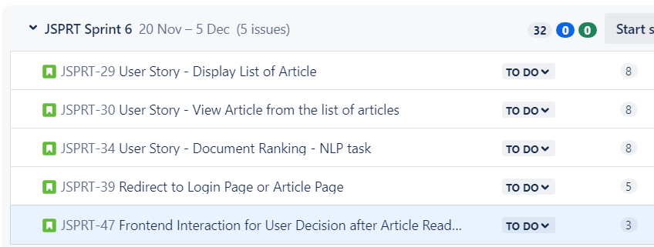

1. **Display List of Articles**

**Size:** 8

**User Role:** Student, Faculty, and Alumni of the University of Michigan

**Goal:** Users should be able to view a list of articles based on their search criteria.

**Reason:** Users can access the top 5 articles according to their preferences.

**Trigger:** Users click the submit button after entering words in the search box.

**Preconditions:** Users should enter keywords and click enter.

**Postcondition:** Users should be able to view a list of articles based on the search criteria.

**Normal Operations:**

* Users enter words in the search box and click the submit button.
* Users receive a list of articles matched to the search criteria.

**Exception:**

* Users cannot retrieve any article list if it does not match the search criteria.
* Users cannot retrieve any article list if they enter null.

**Note:** This user story focuses on providing users with the ability to access a curated list of articles based on their search criteria, enhancing the user experience by tailoring content to their preferences.

1. **View Article from the List of Articles**

**Size:** 3

**User Role:** Student, Faculty, and Alumni of the University of Michigan

**Goal:** Users should be able to search for and read relevant articles.

**Reason:** Users want to read articles matching their interests.

**Trigger:** Users click on a specific article from the list of articles.

**Preconditions:** Users should be able to click on a specific article to read.

**Normal Operations:**

* Users receive a list of articles matching the search criteria they entered.
* Users click on a specific article from the list.

**Postcondition:** Users should be able to read articles.

**Exception:**

* Users cannot view the article if there is no list of articles available that matches the user's search criteria.

**Note:** This user story focuses on the seamless transition from searching for relevant articles to reading them, ensuring a user-friendly experience.

1. **Document Ranking - NLP Task**

**Size:** 8

**User Role:** Developer

**Goal:** Recommend the top 5 articles to the user.

**Reason:** Technical requirement.

**Trigger:** Users enter each criterion in the search box and click the submit.

**Preconditions:** Ranking algorithm calculated to suggest the top 5 articles to users.

**Normal Operations:**

* Users enter each criterion in the search box and click the submit button.
* Users receive the top 5 articles matched to the search criteria they entered.

**Postcondition:** Users will be able to access those articles for defined keywords.

**Exception:**

* Users will not get the top 5 articles if there are not more than 5 articles available that match their search criteria.
* Users will not get any result if there is no article available that matches their search criteria.

1. **User Redirection After Article Reading**

**Size:** 5

**User Role:** Reader (Student, Faculty, Alumni)

**Goal:** Automatically redirect users to either the login page or the article search page upon completing an article reading session.

**Reason:** To enhance user experience by guiding them towards further engagement, either by logging in for personalized content or initiating a new search for additional articles.

**Preconditions:**

* Users have just finished reading an article on the JSPR-Techies blog.

**Triggers:** The user reaches the end of an article.

**Postcondition:** Users are seamlessly redirected to either the login page or the article search page based on their engagement preference.

**Normal Operations:**

* Upon completing an article, users are presented with an option to either log in for personalized content or initiate a new search for additional articles.
* Users selecting the login option are directed to the login page where they can enter their credentials.
* Users opting for a new search are redirected to the article search page, ready to explore more content.

**Exceptions:**

* If the user has already logged in, they are automatically redirected to the article search page.
* Technical issues affecting the redirection functionality may result in users staying on the current page.

**Next Iteration - 11/20/23 - 12/5/23**

**List of the User Stories for the Next Iteration**

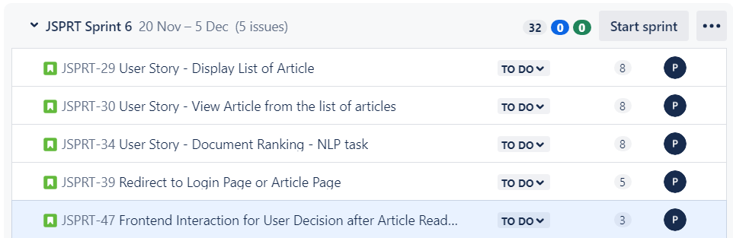

1. **Display List of Articles**

**Size:** 8

**User Role:** Student, Faculty, and Alumni of the University of Michigan

**Goal:** Users should be able to view a list of articles based on their search criteria.

**Reason:** Users can access the top 5 articles according to their preferences.

**Trigger:** Users click the submit button after entering words in the search box.

**Preconditions:** Users should enter keywords and click enter.

**Postcondition:** Users should be able to view a list of articles based on the search criteria.

**Normal Operations:**

* Users enter words in the search box and click the submit button.
* Users receive a list of articles matched to the search criteria.

**Exception:**

* Users cannot retrieve any article list if it does not match the search criteria.
* Users cannot retrieve any article list if they enter null.

**Note:** This user story focuses on providing users with the ability to access a curated list of articles based on their search criteria, enhancing the user experience by tailoring content to their preferences.

1. **View Article from the List of Articles**

**Size:** 3

**User Role:** Student, Faculty, and Alumni of the University of Michigan

**Goal:** Users should be able to search for and read relevant articles.

**Reason:** Users want to read articles matching their interests.

**Trigger:** Users click on a specific article from the list of articles.

**Preconditions:** Users should be able to click on a specific article to read.

**Normal Operations:**

* Users receive a list of articles matching the search criteria they entered.
* Users click on a specific article from the list.

**Postcondition:** Users should be able to read articles.

**Exception:**

* Users cannot view the article if there is no list of articles available that matches the user's search criteria.

**Note:** This user story focuses on the seamless transition from searching for relevant articles to reading them, ensuring a user-friendly experience.

1. **Document Ranking - NLP Task**

**Size:** 8

**User Role:** Developer

**Goal:** Recommend the top 5 articles to the user.

**Reason:** Technical requirement.

**Trigger:** Users enter each criterion in the search box and click the submit.

**Preconditions:** Ranking algorithm calculated to suggest the top 5 articles to users.

**Normal Operations:**

* Users enter each criterion in the search box and click the submit button.
* Users receive the top 5 articles matched to the search criteria they entered.

**Postcondition:** Users will be able to access those articles for defined keywords.

**Exception:**

* Users will not get the top 5 articles if there are not more than 5 articles available that match their search criteria.
* Users will not get any result if there is no article available that matches their search criteria.

1. **User Redirection After Article Reading**

**Size:** 5

**User Role:** Reader (Student, Faculty, Alumni)

**Goal:** Automatically redirect users to either the login page or the article search page upon completing an article reading session.

**Reason:** To enhance user experience by guiding them towards further engagement, either by logging in for personalized content or initiating a new search for additional articles.

**Preconditions:**

* Users have just finished reading an article on the JSPR-Techies blog.

**Triggers:** The user reaches the end of an article.

**Postcondition:** Users are seamlessly redirected to either the login page or the article search page based on their engagement preference.

**Normal Operations:**

* Upon completing an article, users are presented with an option to either log in for personalized content or initiate a new search for additional articles.
* Users selecting the login option are directed to the login page where they can enter their credentials.
* Users opting for a new search are redirected to the article search page, ready to explore more content.

**Exceptions:**

* If the user has already logged in, they are automatically redirected to the article search page.
* Technical issues affecting the redirection functionality may result in users staying on the current page.

**Functionality Completed by the next Iteration**

Describe the functionality that your (partially implemented) system will have at the end of this iteration.

By the end of this iteration, the JSPR-Techies blog will be completed all the functionality listed in the backlog

**Next Iteration Implementation Plan:**

In the upcoming development phase, several critical functionalities are planned for implementation to enhance the overall user experience on the JSPR-Techies platform. The focus is on user authentication and refining the article search process. Additionally, a comprehensive testing plan is outlined to ensure the robustness and reliability of the system.

**User Authentication:**

**Objective:** Users will be able to log in and authenticate with the system seamlessly.

**Implementation Details:** Develop a secure user authentication system, allowing users, including students, faculty, and alumni, to access personalized features and content upon logging in. Integration with University of Michigan credentials may be considered for added security and convenience.

**Article Search Functionality:**

**Objective:** Enable users to efficiently search for articles based on their preferences.

**Implementation Details:** Enhance the search functionality to provide more accurate and relevant results. Consider incorporating filters, sorting options, and an intuitive user interface to streamline the article search process. This improvement aims to make content discovery more intuitive for users.

**Top 5 Article Recommendations:**

**Objective:** Users will receive a curated list of the top 5 articles based on their search criteria.

**Implementation Details:** Implement an advanced recommendation system using algorithms or machine learning models. This system will analyze user behavior, preferences, and search history to generate a tailored list of top 5 articles. The goal is to enhance content discovery and engagement.

**Article Viewing Enhancement:**

**Objective:** Users should have a seamless experience when viewing articles from the list.

**Implementation Details:** Improve the article viewing experience by optimizing the user interface, incorporating multimedia elements, and ensuring fast loading times. This enhancement aims to make the reading process engaging and user-friendly.

**Planning for Testing Phase: Verification and Validation**

As part of the testing phase, a rigorous approach will be taken to ensure the quality and reliability of the implemented functionalities. The following testing activities are planned:

**Code Inspection:**

**Objective:** Review and analyze the codebase to identify and rectify potential issues, ensuring code quality and adherence to coding standards.

**QA Testing for Each Functionality:**

**Objective:** Conduct comprehensive Quality Assurance (QA) testing for each implemented functionality, including user authentication, article search, and recommendation systems. This involves functional testing, regression testing, and performance testing to verify the correctness of the features.

**Stress Testing:**

**Objective:** Evaluate system performance under stress conditions, such as high user loads or concurrent requests. Identify potential bottlenecks and optimize system responsiveness.

**User Acceptance Testing (UAT):**

**Objective:** Engage end-users in the testing process to validate that the implemented features meet their expectations and fulfill user requirements. Gather feedback for further refinement.

By focusing on these future implementations and conducting thorough testing, the aim is to deliver a robust and user-friendly platform for accessing and interacting with articles on the JSPR-Techies blog.

**New User Stories for Next Iteration**

**User Story: Frontend Interaction for User Decision after Article Reading**

**Size:** 3

**User Role:** Reader (Student, Faculty, Alumni)

**Goal:** Engage users in deciding their next action after completing an article reading session.

**Reason:** To provide users with personalized options for a seamless post-reading experience.

**Preconditions:**

* Users have just finished reading an article on the JSPR-Techies blog.

**Triggers:** The user reaches the end of an article.

**Postcondition:** Users make a selection from the presented options, guiding their post-reading experience.

**Normal Operations:**

* Upon completing an article, users are presented with a frontend interface displaying three major input blocks, each representing a different action.
* The first input block prompts users to "Continue Reading" the article, offering the option to delve deeper into the content.
* The second input block allows users to "Sign Out," providing a convenient option for those who have finished their reading session and wish to log out.
* The third input block encourages users to "Return to Article Search," enabling them to explore additional content.
* Users click on their chosen input block to proceed with the selected action.

**Exceptions:**

* If the user has already logged in, the option to "Sign Out" may be dynamically adjusted to reflect their logged-in status.
* Technical issues affecting the presentation of input blocks or user interactions may be addressed promptly through bug fixes or system improvements.

**Backlog Update**

